**CSEE5590/490: Python and Deep Learning Programming (2018 Fall)**

Inclass programming 4

Q1:

1.

Plot graph, loss function and accuracy in the Tensorboard

<http://desktop-oj2oocs:6006/#scalars>

Accuracy and loss:

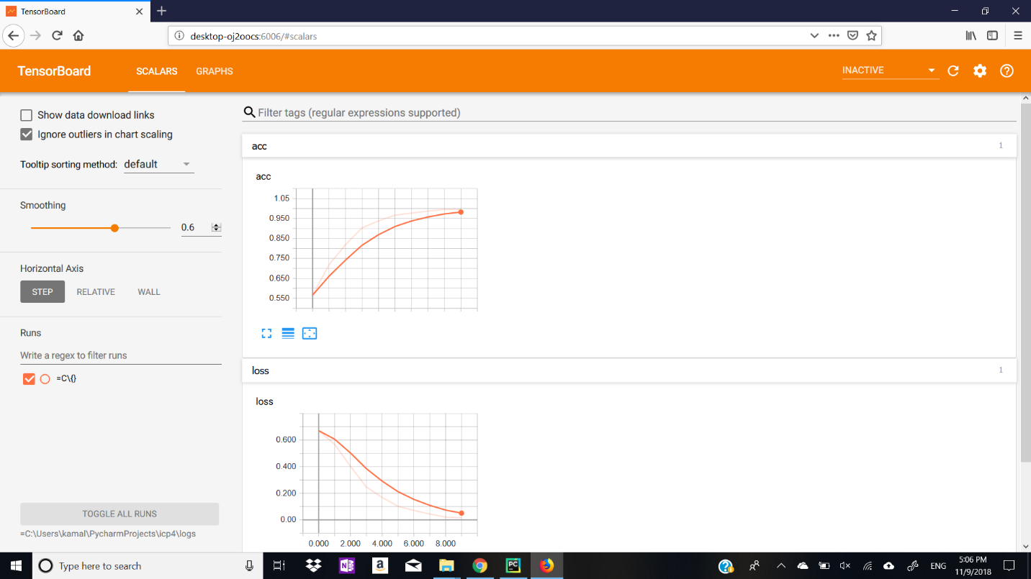

Acc:0.99

Loss:0.016

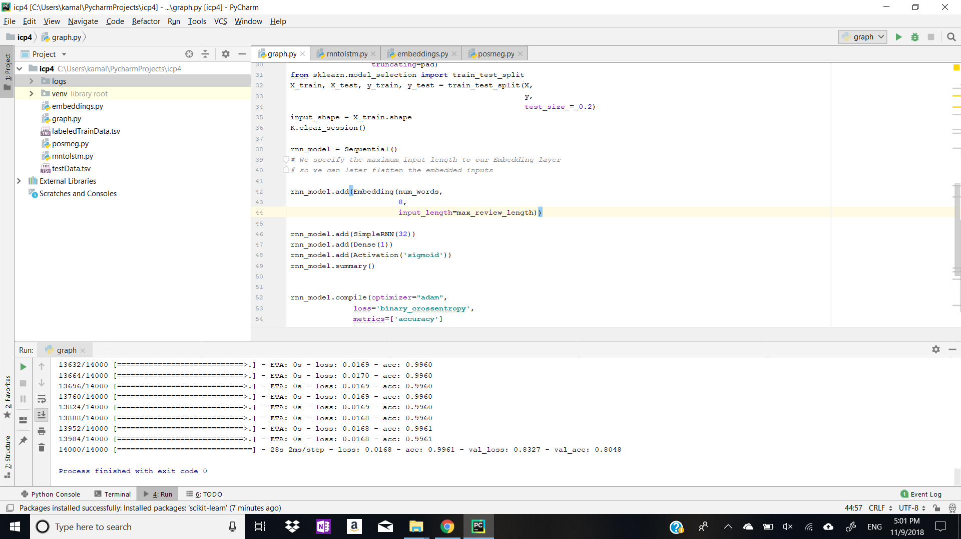

2.Change RNN to LSTM and check loss and accuracy

Rnn: In a RNN, the information cycles through a loop. When it makes a decision, it takes into consideration the current input and also what it has learned from the inputs it received previously.

LSTM: Long Short-Term Memory (LSTM) networks are an extension for recurrent neural networks, which basically extends their memory. Therefore it is well suited to learn from important experiences that have very long time lags in between

Accuracy:0.98

Loss:0.04

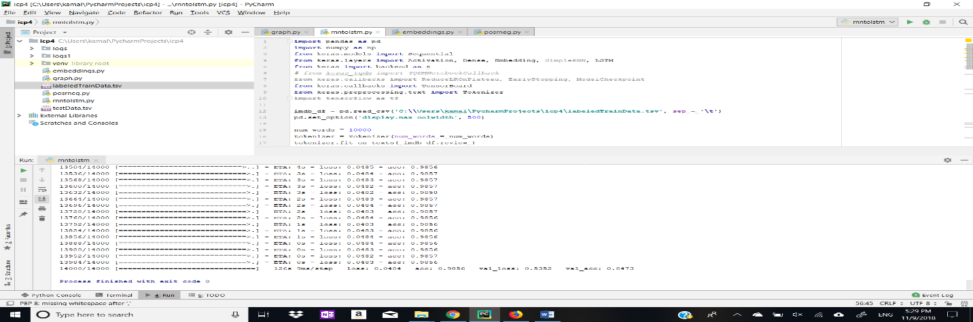

3.changing number of embeeding dimensions from 8 to 4(RNN)

Accuracy:0.94

Loss:0.1590

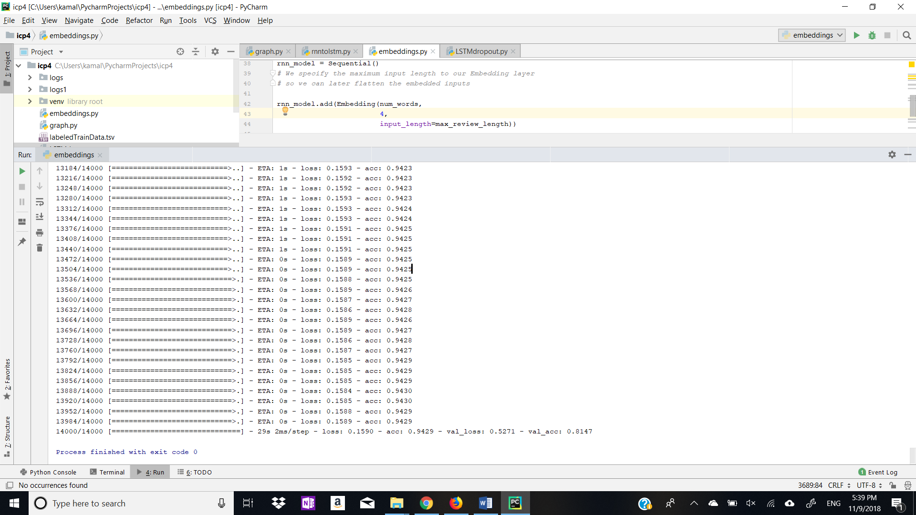

4.Add Dropout to LSTM

This is the command we add to reduce overfitting

rnn_model.add(Dropout(0.1))

An issue with LSTMs is that they can easily **overfit training data**, reducing their predictive skill

Dropout is a regularization method where input and recurrent connections to LSTM units are probabilistically excluded from activation and weight updates while training a network. This has the effect of reducing overfitting and improving model performance.

Accuracy:0.9417

Loss:0.14

